73772214143(Kanishk S)
1.
def playfair_cipher(text, key):
text = text.upper().replace("J", "I").replace(" ", "")
key = key.upper().replace("J", "I")
matrix = "".join(sorted(set(key + "ABCDEFGHIKLMNOPQRSTUVWXYZ"), key=lambda x: (key + "ABCDEFGHIKLMNOPQRSTUVWXYZ").index(x)))
matrix = [matrix[i:i+5] for i in range(0, 25, 5)]

def get_pos(letter):
for r, row in enumerate(matrix):
if letter in row:
return r, row.index(letter)
pairs = []
i = 0
while i < len(text):
if i+1 < len(text) and text[i] != text[i+1]:
pairs.append(text[i] + text[i+1])
i += 2
else:
pairs.append(text[i] + 'X')
i += 1

result = ""
for a, b in pairs:
r1, c1 = get_pos(a)
r2, c2 = get_pos(b)
if r1 == r2:
result += matrix[r1][(c1+1)%5] + matrix[r2][(c2+1)%5]
elif c1 == c2:
result += matrix[(r1+1)%5][c1] + matrix[(r2+1)%5][c2]
else:
result += matrix[r1][c2] + matrix[r2][c1]
return result

text = input("Enter the text: ")
key = input("Playfair Cipher: ")
print("Output:", playfair_cipher(text, key))
output:
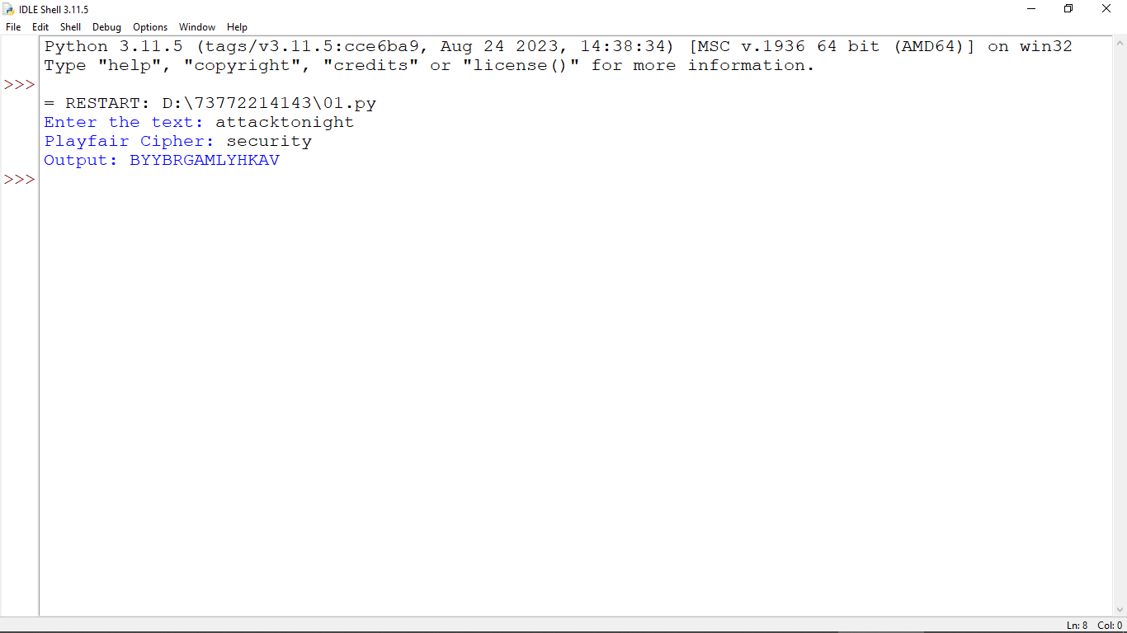

3.
import numpy as np

def hill_cipher(text, key):
text = text.upper().replace(" ", "")
n = int(len(key) ** 0.5)
key_matrix = np.array([[ord(c) - ord('A') for c in key[i*n:(i+1)*n]] for i in range(n)])
text_vector = [ord(c) - ord('A') for c in text]

while len(text_vector) % n != 0:
text_vector.append(ord('X') - ord('A'))

result = ""
for i in range(0, len(text_vector), n):
chunk = np.array(text_vector[i:i+n])
cipher_chunk = key_matrix.dot(chunk) % 26
result += "".join(chr(c + ord('A')) for c in cipher_chunk)
return result

text = input("Enter the text: ")
key = input("Enter key for Hill Cipher: ")
print("Hill Cipher Output:", hill_cipher(text, key))
output:
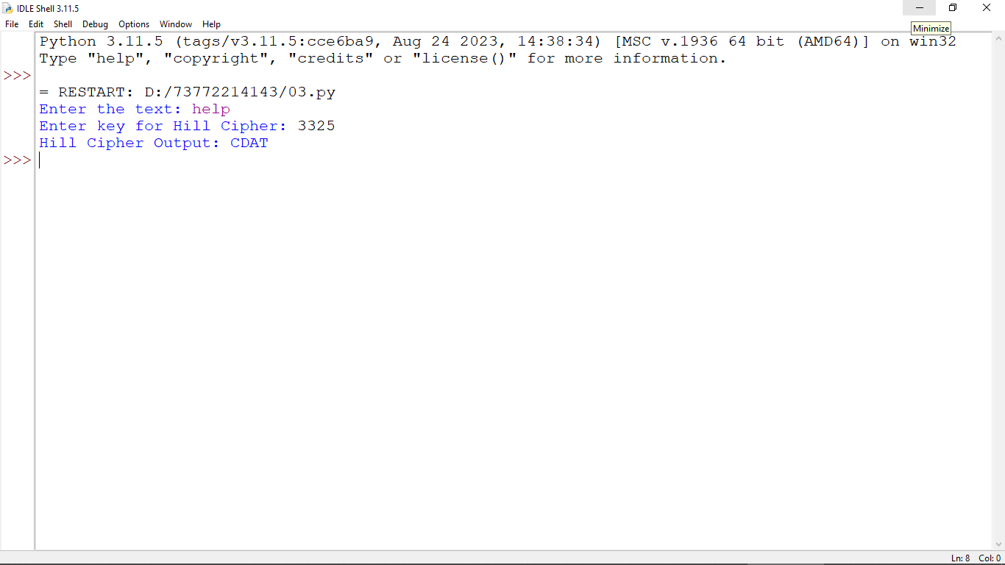
3.
def playfair_cipher(text, key):
text = text.upper().replace("J", "I").replace(" ", "")
key = key.upper().replace("J", "I")
matrix = "".join(sorted(set(key + "ABCDEFGHIKLMNOPQRSTUVWXYZ"), key=lambda x: (key + "ABCDEFGHIKLMNOPQRSTUVWXYZ").index(x)))
matrix = [matrix[i:i+5] for i in range(0, 25, 5)]

def get_pos(letter):
for r, row in enumerate(matrix):
if letter in row:
return r, row.index(letter)
pairs = []
i = 0
while i < len(text):
if i+1 < len(text) and text[i] != text[i+1]:
pairs.append(text[i] + text[i+1])
i += 2
else:
pairs.append(text[i] + 'X')
i += 1

result = ""
for a, b in pairs:
r1, c1 = get_pos(a)
r2, c2 = get_pos(b)
if r1 == r2:
result += matrix[r1][(c1+1)%5] + matrix[r2][(c2+1)%5]
elif c1 == c2:
result += matrix[(r1+1)%5][c1] + matrix[(r2+1)%5][c2]
else:
result += matrix[r1][c2] + matrix[r2][c1]
return result

text = input("Enter the text: ")
key = input("Playfair Cipher: ")
print("Output:", playfair_cipher(text, key))
output:

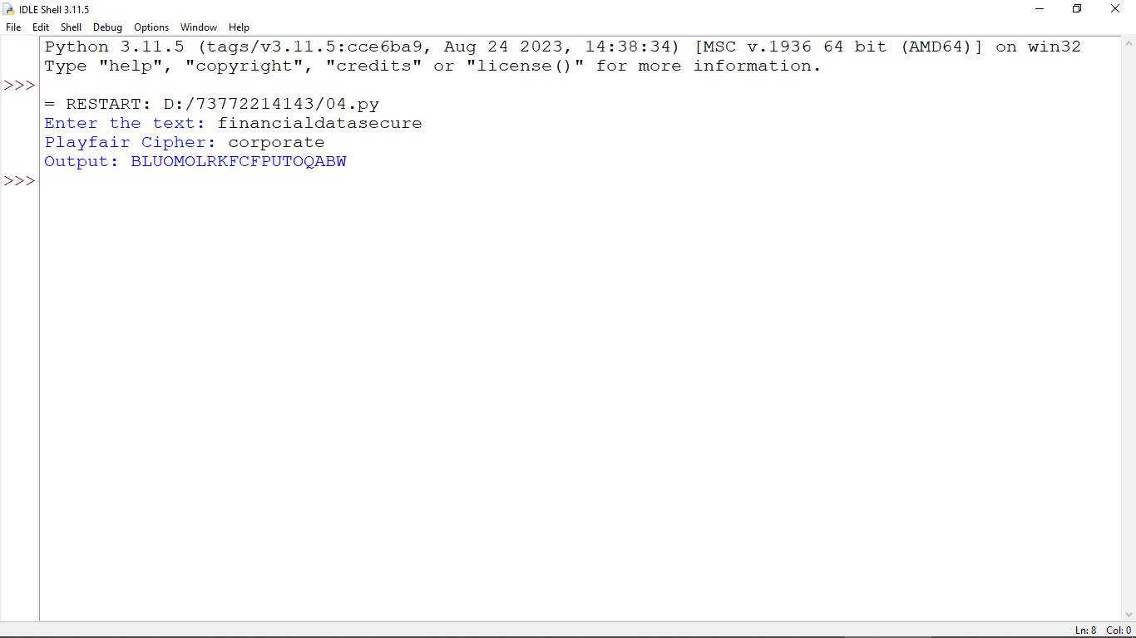

6.
def caesar_cipher(text, shift):
result = ""
for char in text:
if char.isalpha():
shift_amount = shift % 26
new_char = chr(((ord(char.lower()) - 97 + shift_amount) % 26) + 97)
result += new_char.upper() if char.isupper() else new_char
else:
result += char
return result

text = input("Enter the text: ")
shift = int(input("Enter shift for Caesar Cipher: "))
print("Caesar Cipher Output:", caesar_cipher(text, shift))

output:
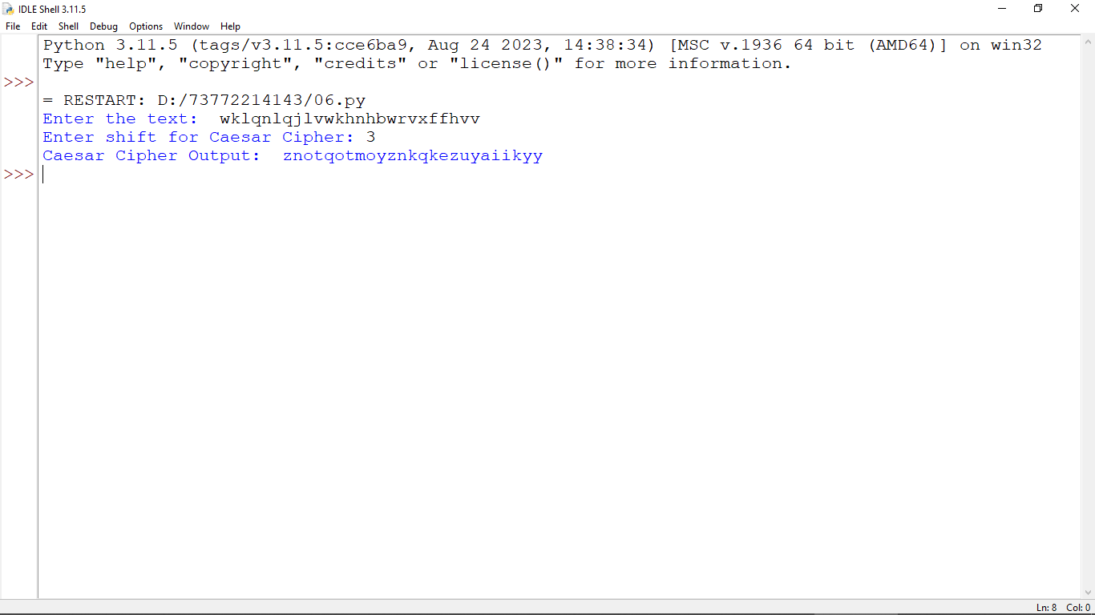

8.
def vigenere_cipher(text, key):
result = ""
key = key.upper()
key_length = len(key)

for i, char in enumerate(text):
if char.isalpha():
shift = ord(key[i % key_length]) - ord('A')
new_char = chr(((ord(char.upper()) - ord('A') + shift) % 26) + ord('A'))
result += new_char.lower() if char.islower() else new_char
else:
result += char
return result

text = input("Enter the text: ")
key = input("Enter key for Vigenere Cipher: ")
print("Vigenere Cipher Output:", vigenere_cipher(text, key))

output:
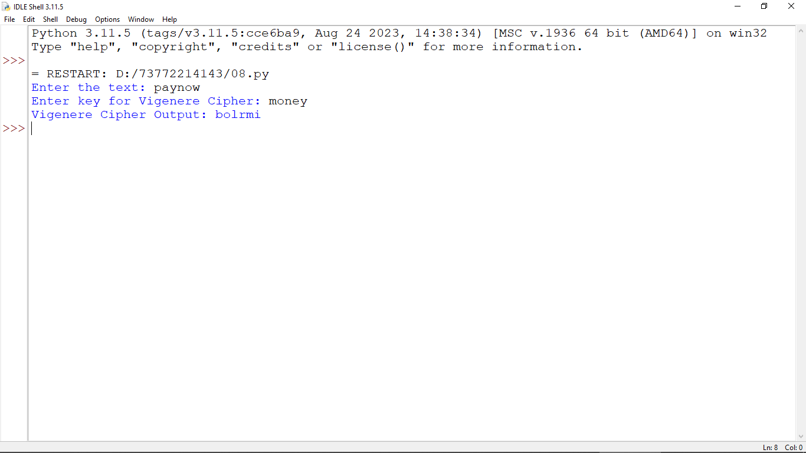

9.
def rail_fence_encrypt(text, rails):
fence = [['\n' for _ in range(len(text))] for _ in range(rails)]
rail = 0
direction = 1

for i in range(len(text)):
fence[rail][i] = text[i]
rail += direction

if rail == 0 or rail == rails - 1:
direction *= -1

result = []
for row in fence:
result.extend([char for char in row if char != '\n'])

return "".join(result)

def rail_fence_decrypt(cipher_text, rails):
fence = [['\n' for _ in range(len(cipher_text))] for _ in range(rails)]
rail = 0
direction = 1

for i in range(len(cipher_text)):
fence[rail][i] = '*'
rail += direction

if rail == 0 or rail == rails - 1:
direction *= -1

index = 0
for row in range(rails):
for col in range(len(cipher_text)):
if fence[row][col] == '*' and index < len(cipher_text):
fence[row][col] = cipher_text[index]
index += 1

result = []
rail = 0
direction = 1

for i in range(len(cipher_text)):
result.append(fence[rail][i])
rail += direction

if rail == 0 or rail == rails - 1:
direction *= -1

return "".join(result)

text = input("Enter the text: ")
rails = int(input("Enter number of rails: "))

cipher_text = rail_fence_encrypt(text, rails)
print("Encrypted Text:", cipher_text)
decrypted_text = rail_fence_decrypt(cipher_text, rails)
print("Decrypted Text:", decrypted_text)
output:
